

SNAR20 RC Arduino tank robot arm

Done by: Jana Hariri S22208115-Hajer Bakoor S212107483
Maha Alblwai S22107905-Mohammed Rabee S23108703
Instructor: Dr. Nema Selam
Course: Microprocessor Systems-spring 2024

Introduction:

The SNAR20 RC Arduino tank robot arm is an innovative and adaptable robotic arm engineered to deliver advanced control and capability across a range of applications. The objective of this project is to present a thorough overview and analysis of the SNAR20 RC Arduino tank robot arm, examining its features, functionalities, and possible uses. The SNAR20 provides a unique platform for experimentation, automation, and remote control operations by fusing the strength and adaptability of Arduino programming with the mobility and dexterity of a robotic arm in the tank design. This study will analyze the design, mechanics, control system, and prospective applications of the SNAR20 RC Arduino tank robot arm. It aims to provide insights into the notable contributions and opportunities that this robot arm offers to the world of robotics.

Components:
- 1 Arduino Uno
- 1 motor shield
- 2 (3.7) batteries
- 4 mg996r servo motor
- 1260 motor
- 1 controller
- 6 wheels
- 1 robotic arm
- Wiring and connectors

Arduino Uno:
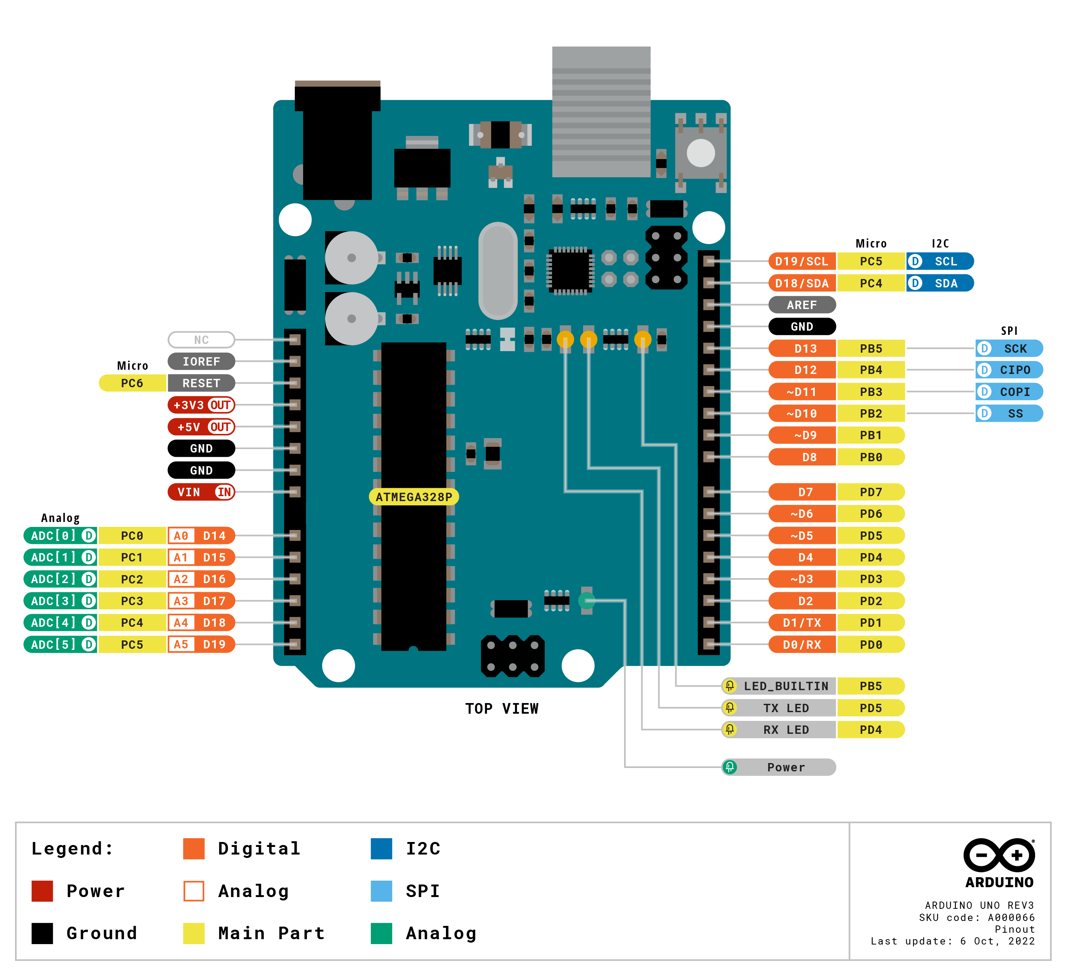
is a microcontroller board based on the ATmega328P (datasheet). It has 14 digital input/output pins (of which 6 can be used as PWM outputs), 6 analog inputs, a 16 MHz ceramic resonator (CSTCE16M0V53-R0), a USB connection, a power jack, an ICSP header and a reset button. It contains everything needed to support the microcontroller; simply connect it to a computer with a USB cable or power it with a AC-to-DC adapter or battery to get started.. You can tinker with your Uno without worrying too much about doing something wrong, worst case scenario you can replace the chip for a few dollars and start over again.

Tech specs
Microcontroller | ATmega328P
Operating Voltage | 5V
Input Voltage (recommended) | 7-12V
Input Voltage (limit) | 6-20V
Digital I/O Pins | 14 (of which 6 provide PWM output)
PWM Digital I/O Pins | 6
Analog Input Pins | 6
DC Current per I/O Pin | 20 mA
DC Current for 3.3V Pin | 50 mA
Flash Memory | 32 KB (ATmega328P) of which 0.5 KB used by bootloader
SRAM | 2 KB (ATmega328P)
EEPROM | 1 KB (ATmega328P)
Clock Speed | 16 MHz
LED_BUILTIN | 13
Length | 68.6 mm
Width | 53.4 mm
Weight | 25 g

Arduino Motor Shield:
is based on the L298 (datasheet), which is a dual full-bridge driver designed to drive inductive loads such as relays, solenoids, DC and stepping motors. It lets you drive two DC motors with your Arduino board, controlling the speed and direction of each one independently. You can also measure the motor current absorption of each motor, among other features. The shield is TinkerKit compatible, which means you can quickly create projects by plugging TinkerKit modules to the board.

Tech specs
Operating Voltage | 5V to 12V
Motor controller | L298P, Drives 2 DC motors or 1 stepper motor
Max current | 2A per channel or 4A max (with external power supply)
Current sensing | 1.65V/A
Power
The Arduino Motor Shield must be powered only by an external power supply. Because the L298 IC mounted on the shield has two separate power connections, one for the logic and one for the motor supply driver. The required motor current often exceeds the maximum USB current rating.
External (non-USB) power can come either from an AC-to-DC adapter (wall-wart) or battery. The adapter can be connected by plugging a 2.1mm center-positive plug into the Arduino's board power jack on which the motor shield is mounted or by connecting the wires that lead the power supply to the Vin and GND screw terminals, taking care to respect the polarities.
To avoid possible damage to the Arduino board on which the shield is mounted, we reccomend using an external power supply that provides a voltage between 7 and 12V. If your motor require more than 9V we recommend that you separate the power lines of the shield and the Arduino board on which the shield is mounted. This is possible by cutting the "Vin Connect" jumper placed on the back side of the shield. The absolute limit for the Vin at the screw terminals is 18V
Input and output
This shield has two separate channels, called A and B, that each use 4 of the Arduino pins to drive or sense the motor. In total there are 8 pins in use on this shield. You can use each channel separately to drive two DC motors or combine them to drive one bipolar stepper motor. The shield's pins, divided by channel are shown in the table below:
Function | pins per Ch. A | pins per Ch. B
Direction | D12 | D13
PWM | D3 | D11
Brake | D9 | D8
Current Sensing | A0 | A1

If you don't need the Brake and the Current Sensing and you also need more pins for your application you can disable this features by cutting the respective jumpers on the back side of the shield.
The additional sockets on the shield are described as follow:
- Screw terminal to connect the motors and their power supply.
- 2 TinkerKit connectors for two Analog Inputs (in white), connected to A2 and A3.
- 2 TinkerKit connectors for two Aanlog Outputs (in orange in the middle), connected to PWM outputs on pins D5 and D6.
- 2 TinkerKit connectors for the TWI interface (in white with 4 pins), one for input and the other one for output.

Motors Connection
Brushed DC motor. You can drive two Brushed DC motors by connecting the two wires of each one in the (+) and (-) screw terminals for each channel A and B. In this way you can control its direction by setting HIGH or LOW the DIR A and DIR B pins, you can control the speed by varying the PWM A and PWM B duty cycle values. The Brake A and Brake B pins, if set HIGH, will effectively brake the DC motors rather than let them slow down by cutting the power. You can measure the current going through the DC motor by reading the SNS0 and SNS1 pins. On each channel will be a voltage proportional to the measured current, which can be read as a normal analog input, through the function analogRead() on the analog input A0 and A1. For your convenience it is calibrated to be 3.3V when the channel is delivering its maximum possible current, that is 2A.

Physical Characteristics
The maximum length and width of the Motor Shield PCB are 2.7 and 2.1 inches respectively. Four screw holes allow the board to be attached to a surface or case. Note that the distance between digital pins 7 and 8 is 160 mil (0.16"), not an even multiple of the 100 mil spacing of the other pins.

MG996R servo motor:
The MG996R is a metal gear servo motor with a maximum stall torque of 11 kg/cm. Like other RC servos the motor rotates from 0 to 180 degree based on the duty cycle of the PWM wave supplied to its signal pin.

Wire Configuration
Wire Number | Wire Colour | Description
1 | Brown | Ground wire connected to the ground of system
2 | Red | Powers the motor typically +5V is used
3 | Orange | PWM signal is given in through this wire to drive the motor

Tech specs
Operating Voltage | +5V typically
Current | 2.5A (6V)
Stall Torque | 9.4 kg/cm (at 4.8V)
Maximum Stall Torque | 11 kg/cm (6V)
Operating speed | 0.17 s/60°
Gear Type | Metal
Rotation | 0°-180°
Weight of motor | 55gm

Most of the hobby Servo motors operates from 4.8V to 6.5V, the higher the voltage higher the torque we can achieve, but most commonly they are operated at +5V. Almost all hobby servo motors can rotate only from 0° to 180° due to their gear arrangement so make sure your project can live with the half circle if no, you can prefer for a 0° to 360° motor or modify the motor to make a full circle. The gears in the motors are easily subjected to wear and tear, so if your application requires stronger and long running motors you can go with metal gears or just stick with normal plastic gear.

The 1260 Motor:
The 1260KV motor is a 4-POLE 12-SLOT design that boasts exceptional EFFICIENCY and produces LESS HEAT. It is the perfect upgrade for any 1/6th scale vehicles weighing up to 20 lbs and running up to 8s LiPo; it is also a great upgrade for drivers looking for a reliable, high torque 8s motor for their 1/8th scale vehicles.
The 1260kv has a lower wattage/power rating compared to the 1650kv; as such the 1260kv will run hotter than the 1650kv when geared for the same speed. For higher power applications (IE speed and drag setup), the 1717-1650kv is preferred with appropriate gearing. High-strength, high-temperature grade neodymium sintered magnets combined with High-strength Kevlar wrap ensures the integrity of the rotor is not compromised during harsh running conditions.
Without a robust and reliable design, efficiency will only go so far. RC enthusiasts love pushing their equipment to the edge. Engineers know this and spared no expense when developing a design that could hold up to the harsh conditions that the RC community will throw at it, resulting in a cooler running motor. A cooler motor has a longer lifetime. Construction of our motor required careful component selection; each verified through internal testing to ensure the HIGHEST EFFICIENCY possible. In the end, the result is a motor with unmatched quality, performance, and reliability.

Application | Ideal for 1/6 scale vehicles up to 20lbs running 6s – 8s LiPo; it is also a great upgrade for drivers looking for a reliable, high torque 8s motor for their 1/8th scale vehicles.
Max weight | 20lbs
Input voltage | 3s-8s
Kv | 1260
Max RPM | 56,000
Size | Length 3.35”(85.1mm)  Diameter 1.87 (47.6mm)
Weight (with wires) | 597.6g (21.08 oz); 548g without wires
Shaft size | 5mm
Mounting hole specifications: | M3 and M4 @ 25.4mm (1.0 inch)
Connectors | 6.5mm
Speed | 500 RPM

Comparison between the servo motor and the 1260 motor:

 | Servo Motor: | 1260 Motor:
Control Interface: | Servo motors are commonly controlled using pulse width modulation (PWM) signals. The position and speed of the motor can be controlled by varying the pulse width and frequency of the PWM signal. | The control interface for the 1260 motor would depend on its specific design and specifications. It could use various control methods, such as PWM, analog voltage control, or digital communication protocols.
Power and torque: | 9.4 kg/cm (at 4.8V) | 8s motor for their 1/8th scale
Input voltage: | 4.8 to 6v | 3s-8s
Application: | robotics, automation, 3D printing, camera stabilization systems, and aerospace controls. | it is also a great upgrade for drivers looking for a reliable, high torque motors
Revolutions per minute: | 60 | 56,000
Dimensions: | Length: 40.7 mm x Width: 19.7 mm x Height: 42.9 mm | Length,85.1mm x Diameter,47.6mm

IR controller:

The Infrared IR Wireless Remote Control Module Kit for Arduino consists of ultra-thin infrared remote control and 38KHz infrared receiver module. This mini slim infrared remote control with 20 function keys. Its transmit distances up to 8 meters. Ideal for handling a variety of equipment indoors.
IR receiver module can receive a standard 38KHz modulation remote control signal. You can decode the remote control signal through Arduino programming. You can design a variety of remote control robots and interactive works.

Features :
- Depending on the surrounding environment and the sensitivity of the receiver the transmission distance may be affected.
- Photo-detector and preamplifier in one package.
- Internal filter for PCM frequency.
- Improved shielding against EMI.

Transmission distance | up to 8m(depending on the surrounding environment, the sensitivity of the receiver, etc).
Sticking material | 0.125mmPET
Effective life | 20,000 times
Static current | 3uA – 5uA
Dynamic current | 3mA – 5mA
Battery | CR2025 Button batteries
Length (mm): | 86
Width (mm): | 40
Height (mm): | 6.5
Weight (g): | 10
Weight | 0.015 kg
Dimensions | 15 × 8 × 2 cm
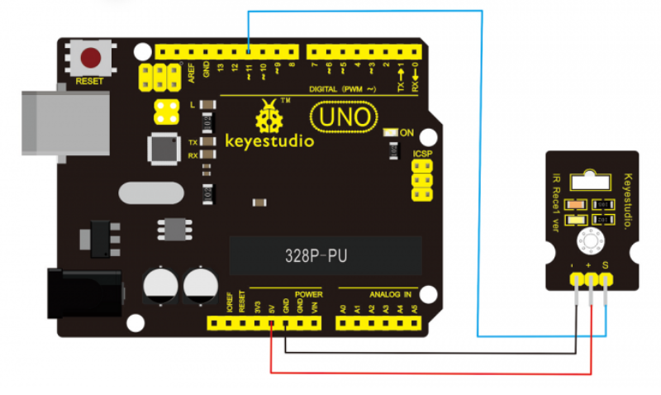
Voltage amplifier:

A voltage amplifier; it stores more ampere while lowering the voltage received from the battery. Which was a challenge discussed with the Dr. in the presentation. However, all other designs are still valid.
One kind of DC motor that can be utilized in robotics applications with Arduino microcontrollers is the 1260 motor. Here's a quick rundown of how an Arduino-based robot may incorporate a 1260 motor:

1. A Brief Overview of the 1260 Motor: Often utilized for high-torque applications, the 1260 motor is a compact, strong DC motor. It may be controlled with a variety of Arduino-compatible motor drivers and runs at a specified voltage.

2. Motor Driver: An Arduino requires a motor driver, such as the L298N, to operate a 1260 motor.Using the digital pins on the Arduino, you may regulate the motor's direction and speed with this driver.

3. Wiring the Motor: Make sure the motor driver and 1260 motor relate to the proper polarity.Next, link the Arduino and the driver. To power the motor, make sure the motor driver is connected to the power supply.

4. Arduino programming: Create a sketch, or program, to instruct the Arduino on how to operate the motor. The motor's direction and speed can be adjusted using functions. For instance, you could use analogWrite() to provide the driver a PWM signal so that the motor spins.
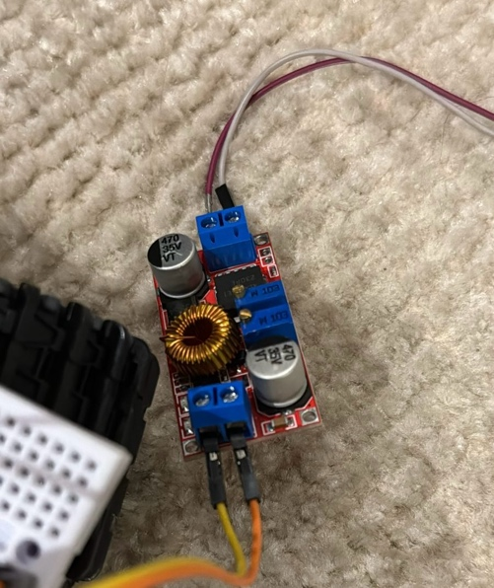
5. Testing: Turn on the circuit to test the motor after uploading the code to the Arduino. To get the required motor behavior, modify the code as necessary.

3.7V Lithium-Ion:
Size | 18650
Voltage | 3.7v
Capacity | 2.6Ah
Chemistry | Lithium-Ion
Terminal Type | Standard
Operating Temperature Range | -20 → +60°C
Resistance | 250mΩ

Features and Benefits.
- Lithium-Ion 18650 rechargeable battery.
- PCP Protected with internal PCB voltage protection
- Designed for LED high power torches and other high draining devices.
- Built-in overcharge protection.
- Built-in over discharge protection,
- Built-in over current and short protection
- High quality Li-ion rechargeable battery.
- Long battery life.
- Use a dedicated battery charger.

Applications.
- High intensity torches.
- LED Power torches.
- Electronics.
- High draining devices.

Design with Six Wheels:
A six-wheeled robot, also called a rover, is made to navigate over a range of terrain and obstructions.
The robot's controller serves as its brain. It receives data from the robot's sensors, interprets it, and then transmits commands to the actuators—in this example, the wheels' motors. A microcontroller, a single-board computer, or any other programmed logic device can serve as the controller.
Because it offers the following features, this design is very well-liked in planetary exploration robots like the Mars rovers:

Increased Stability: Proper weight distribution and balance are achieved with more wheels.
Increased Traction: Having more wheels makes for more surface area in contact with the ground, which increases grip.
Obstacle Clearance: By allowing the extra wheels to be suspended separately, the robot may climb over obstacles without tipping over.
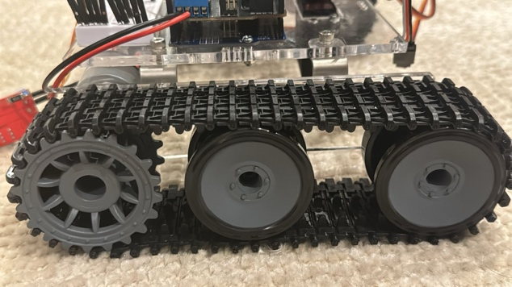

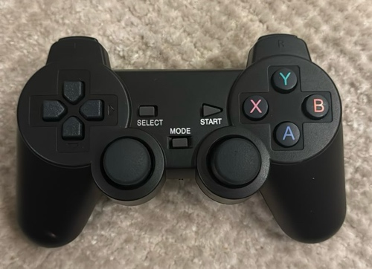
1 controller:
The robot's controller serves as its brain. It receives data from the robot's sensors, interprets it, and then transmits commands to the actuators— in this example, the wheels' motors. A microcontroller, a single-board computer, or any other programmed logic device can serve as the controller.

How to install the robotic arm:
There are numerous installation techniques available for the robotic arm. The module is extremely flexible and straightforward to set up based on your specific requirements.

step1 : install the base
- The base was provided form the company with the kit with a manual that only described to us how to build the base.
- The manual was in Chinese, so we had to translate it.
- After that we attach the 2 sets of 6 wheels to the base, where they are an essential part of the robotics arms movement.
- Pay attention to the angle when the steering gear 2 is installed, 45 degrees obliquely upward
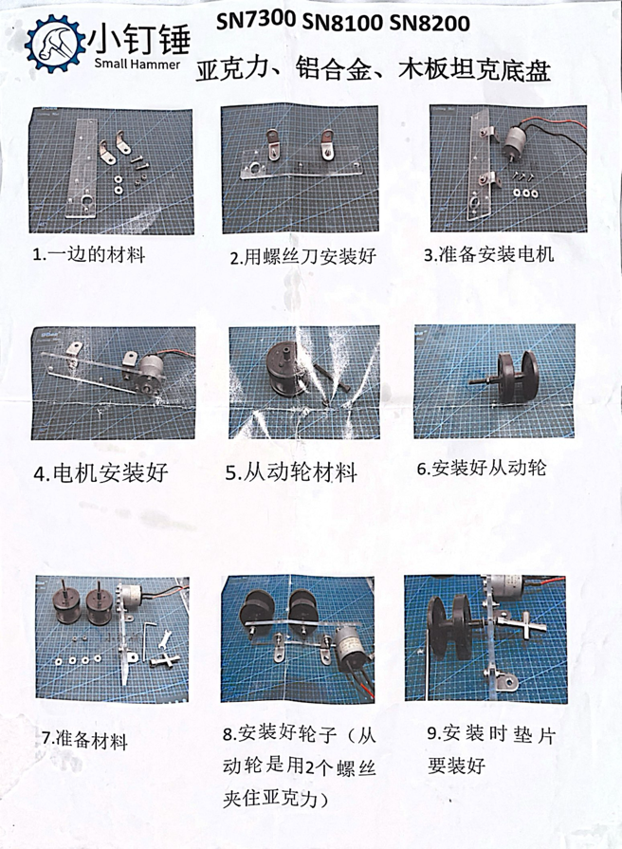
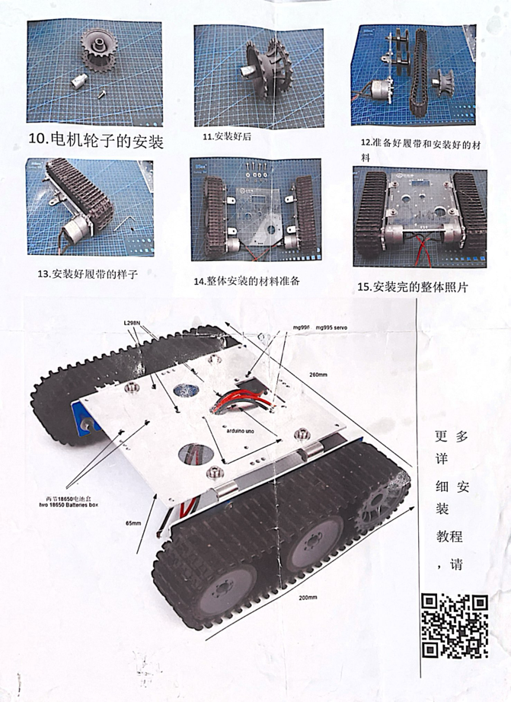

Step 2: Install the mechanical claw
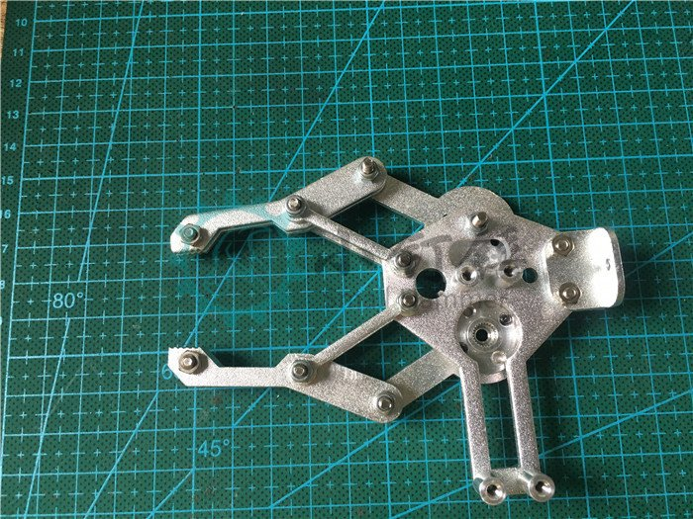
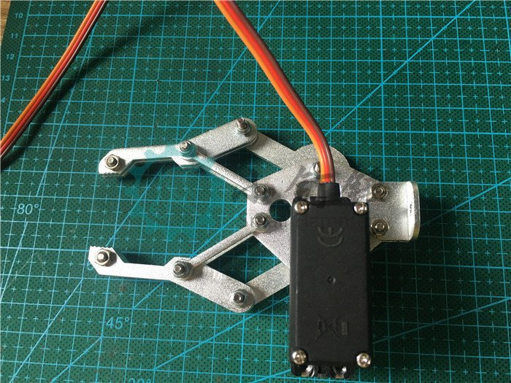

- We stared by creating room for the installation for the streering gear
- We then placed the steering gear into the specified position then attaching the steering gear making sure they are properly aligned with the corresponding holes on the assembly.
- After ensuring that the screws are tightly secured, we make sure that the streering base is is properly secured to the base
- After successfully installing the steering base, we readjust the paws to their original position.

Step 3 : connect the arm to the claw

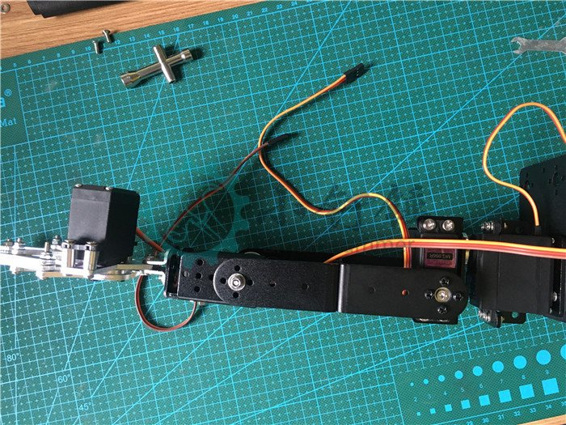
- We partially open the paws to make room for the installation by placing the steering gear to the base to attach them to each other and making sure they are securely attached
- We securely attach the claw to the robotic arm
- After adjusting the settings and making sure that the arm is securely attach to the base
- We check if the claws are parallel to one another.
- To make sure the assembly is secure, double-check that all of the screws are tight.

Conclusion:
This project analyzes the SNAR20 RC Arduino tank robot arm, a unique platform for experimentation, automation, and remote-control operations. It examines its design, mechanics, control system, and potential applications, offering insights into its contributions and opportunities to the robotics world. The arm combines Arduino programming strength with robotic arm mobility. We faced a challenge of amplifying velocity to the designed robot, the circuit of the robot could not handle more than 5V, so we added a voltage amplifier to the design to modify the voltage distribution by giving in more ampere than voltage.

References:
RS PRO, 3.7V, 18650, Lithium-Ion Rechargeable Battery, 2.6Ah. (n.d.). RS Components Saudi. https://sa.rsdelivers.com/product/rs-pro/rs-pro-37v-18650-lithium-ion-rechargeable-battery/8801558
Arduino Uno Rev3. (n.d.). Arduino Official Store. https://store.arduino.cc/products/arduino-uno-rev3
Arduino Motor Shield Rev3. (n.d.). Arduino Official Store. https://store.arduino.cc/products/arduino-motor-shield-rev3
MG996R Servo Motor. (n.d.). Components101. https://components101.com/motors/mg996r-servo-motor-datasheet
Castle 1717 Sensored Motor - 1260Kv. (n.d.). https://www.castlecreations.com/en/castle-1717-sensored-motor-1260kv-060-0082-00
What is a Servo Motor? | Lin Engineering. (n.d.). https://www.linengineering.com/what-is-a-servo?gad_source=1&gclid=CjwKCAjwl4yyBhAgEiwADSEjeHGSJ4z8CU8iMKP95onQgbQSzUSpCysrHkI1Fjl11QYao2c0YbcYORoC8bIQAvD_BwE
Aalst, W. M. P. van der/Bichler, D./Heinzl, A (2018). Robotic Process Automation, in: Business & Information Systems Engineering, 60 (4), pp. 269-272.

Alexander, S./Haisermann, A./Schabicki, T./Frank, S. (2018). Robotic Process Automation (RPA) im Rechnungswesen und Controlling – welche Chancen ergeben sich?, in: Controlling – Zeitschrift für erfolgsorientierte Unternehmenssteuerung, 30 (3), pp. 11-19.

Camin, T. (2018). Roboter im Shared Service Center, in: Controlling & Management Review, 62 (8), pp. 30-37.
Cooper, L. A./Holderness, D. K./Sorensen, T. L./ Wood, D. A. (2019). Robotic Process Automation in Public Accounting, in: Accounting Horizons, 33 (4), pp. 15-35.

Gartner (2019). Magic Quadrant for Robotic Process Automation Soft ware. Retrieved on 20.02.2020, from https://www.uipath. com/de/company/rpa-analyst-reports/gartner-magic- quadrant-robotic-process-automation

Institute for Robotic Process Automation & Artificial Intelligence (2019). Definition and Benefits. Retrieved on 06.05.2020, from https://irpaai.com/definition-and-benefits/

Jennings, D.; Figliozzi, M. Study of Sidewalk Autonomous Delivery Robots and Their Potential Impacts on Freight Efficiency and Travel. Transp. Res. Rec. 2019, 2673, 317–326.

Hoffmann, T.; Prause, G. On the regulatory framework for last-mile delivery robots. Machines 2018, 6, 33.

Patil, U.; Gujarathi, A.; Kulkarni, A.; Jain, A.; Malke, L.; Tekade, R.; Paigwar, K.; Chaturvedi, P. Deep Learning Based Stair Detection and Statistical Image Filtering for Autonomous Stair Climbing. In Proceedings of the 3rd IEEE International Conference on Robotic Computing, IRC 2019, Naples, Italy, 25–27 February 2019; pp. 159–166.

